SeaLife Tech advice
For SeaLife Service Centers only

Date: Sept 1, 2009

Subject: DC1000 lens reflection shows up in picture

Applies to: All DC1000 cameras with SL970 wide angle lens attached. Problem occurs only when directing camera towards sun, bright light source or over-flashing the subject.

Symptoms: Lens reflection shows up in picture. See sample pictures.
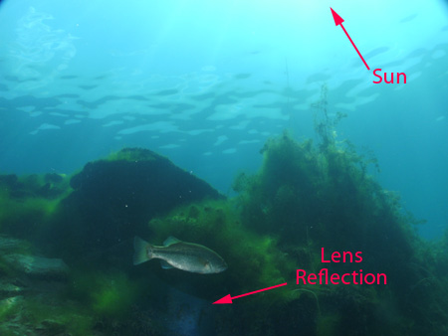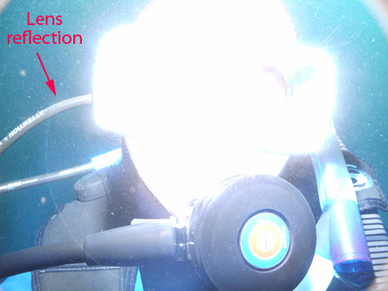

Cause: The inner camera lens ring is reflecting the bright light towards the wide angle lens, which then reflects the ring back into the camera lens and image sensor. The reflection is not common, but may occur when directing the camera towards a very bright light source, like the sun or an over-flashes subject.

Solution: Attach a non-reflective sticker to the camera lens ring as show below. SeaLife we anti-reflective lens rings to all service centers at no cost.

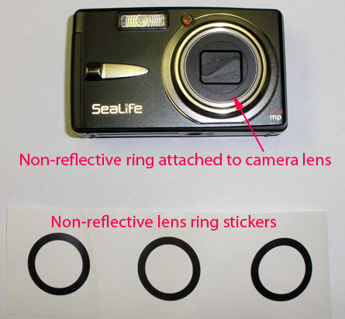

Warranty: Not applicable

Repair: Mail one non-reflective sticker to any customer who experiences this problem and would like a solution.

